Home Assignment – Selenium to PW Converter

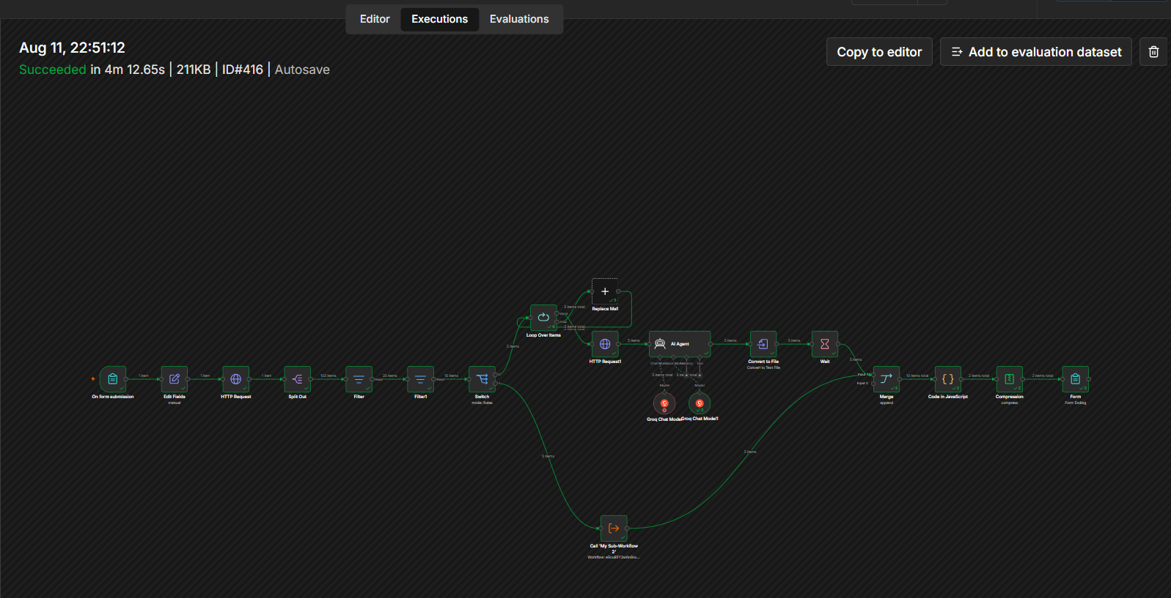
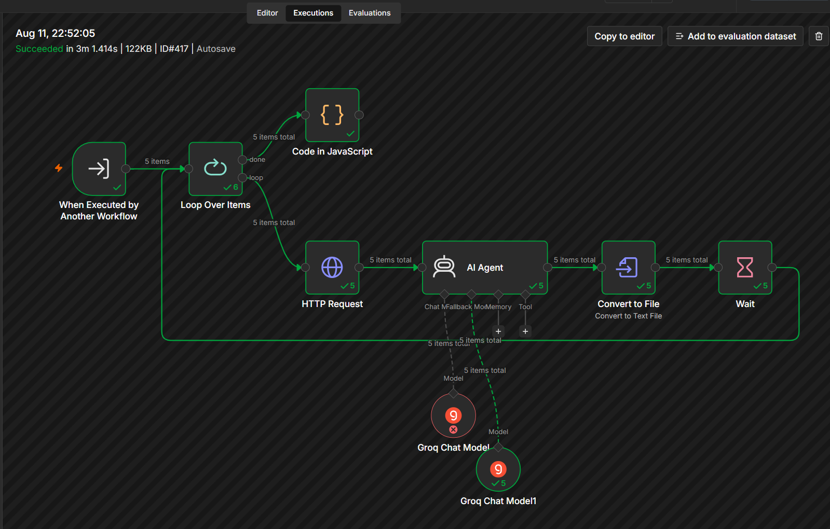
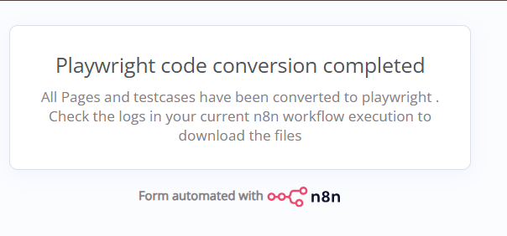
Result
Challenges and Learnings
# | Challenge | What was happening | Resolution
1 | GitHub Repo URL parsing | The workflow received a full GitHub repository URL such as https://github.com/owner/repository, but subsequent GitHub API nodes needed the owner and repository name separately. | Parsed the URL and extract the repository owner and repo name before calling GitHub APIs.
2 | Incorrect GitHub URL structure | GitHub API endpoints were being constructed with the complete URL instead of the required API path/parameters. | Converted the repository URL into values such as owner = ... and repo = ..., then used those values in the GitHub API request.
3 | GitHub Trees API returning 404 | The GitHub Trees request was pointing to an invalid/nonexistent repository or using the wrong owner/repository values. | Verify the parsed owner and repo, then constructed the Trees API request using the correct repository and branch/ref.
4 | Branch/ref issue | The repository tree request depends on a valid branch/ref. A missing or incorrect ref can cause the GitHub request to fail. | Used the repository's actual default branch/ref and pass it correctly to the GitHub Trees API.
5 | GitHub response structure | The GitHub API response contains tree entries rather than directly returning the file contents needed by later nodes. | Processed the returned tree array and identify the files that need to be downloaded/processed.
6 | Filtering repository files | The workflow was receiving multiple GitHub tree entries, including directories and files that were not required. | Added filtering logic to select the required file types/paths before continuing.
7 | Multiple files entering the workflow | After filtering, multiple files were passed to downstream nodes, making it important to preserve each file as a separate n8n item/binary property. | Keep each file as its own item and ensure the binary property is consistently named, typically data.
8 | Binary data handling | The workflow showed messages such as “Only binary data exists. View it using the Binary tab.” This meant the file existed as binary data rather than normal JSON. | Treat the file through the Binary tab/property and use nodes that explicitly support binary input.
9 | Convert to File / binary field confusion | Nodes downstream expected a particular binary property, but the incoming binary field name did not always match. | Check the Binary tab and use the exact binary property name, e.g. data, in the node configuration.
10 | Code node merging files | The Code node was changed to dynamically collect multiple binary files rather than hard-coding only one file. | Use $input.all() and dynamically create properties such as file1, file2, file3, etc.
11 | Compression using only file1 | Even though the Code node produced file1, file2, file3, etc., the compression node was configured for only one binary property. | Configure compression to consume the correct binary inputs rather than assuming only file1.
12 | All test cases entered the sub-workflow, but only one reached the parent workflow | The sub-workflow processed all 5 items successfully, but its final output was reduced to 1 item. | Preserve all items at the end of the sub-workflow using $input.all(). The parent Call My Sub-Workflow node should then receive all 5 items.

Code Corrections
Subworkflow Code in Javascript

OLD: return $('Convert to File').all();
NEW: return $input.all();
Purpose: Return ALL converted test cases.

Main workflow Code in Javascript
OLD: file${index + 1}
NEW: file${fileIndex} + fileIndex++
Purpose: Prevent binary files from overwriting each other.

Most important lessons from the troubleshooting
- Don't pass the complete GitHub URL where the API expects owner/repo.
- Validate owner, repo, and ref/branch before troubleshooting the GitHub Trees API.
- Binary data and JSON data are different in n8n. A file visible under the Binary tab isn't necessarily available under $json.
- Use $input.all() when the Code node needs to work with all incoming files.
- Use a separate file counter for binary aggregation. index + 1 refers to the item, not each binary file inside that item. Multiple binaries within one item can therefore overwrite each other.

